AWS TASK 2:

Screenshot 1: VPC Creation
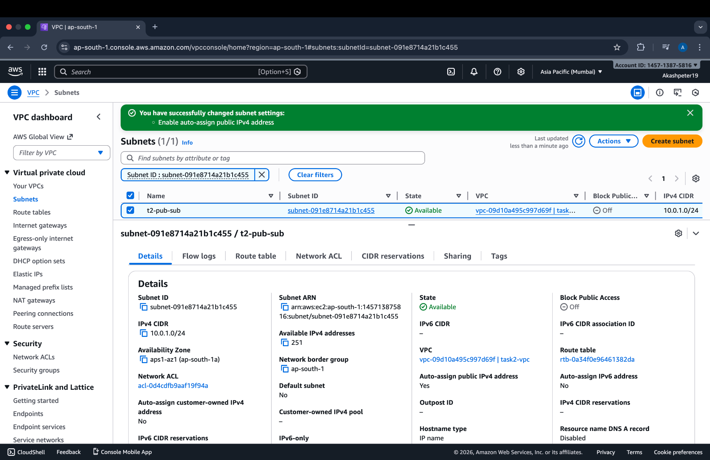
This screenshot shows the successful creation of a custom VPC with the CIDR block 10.0.0.0/16, which acts as the main private network for this task.

Screenshot 2: Internet Gateway
This screenshot shows the Internet Gateway created and attached to the VPC, which enables internet access for resources in the public subnet.

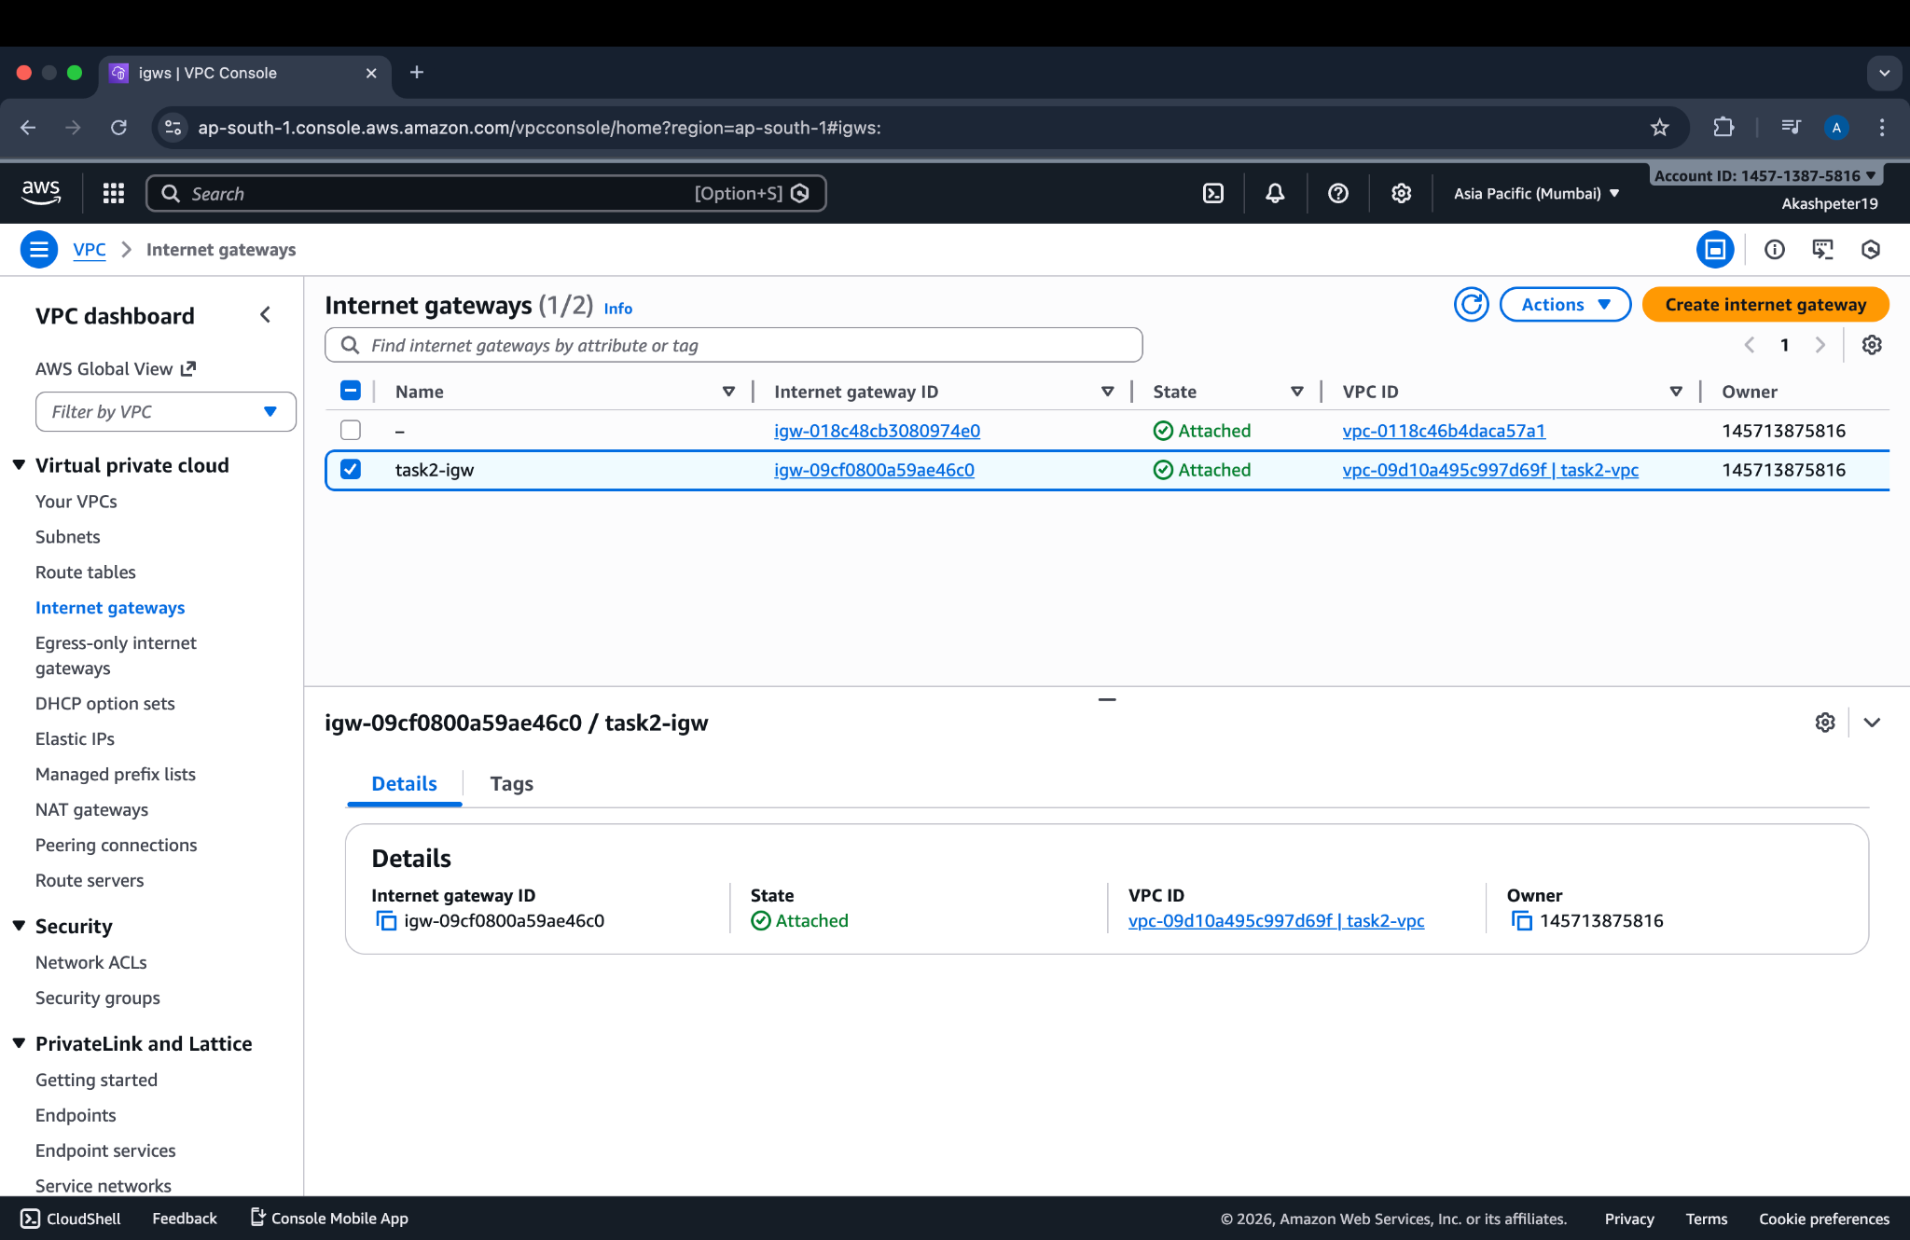

Screenshot 3: Public Subnet
This screenshot shows the public subnet created with CIDR block 10.0.1.0/24, configured to automatically assign public IP addresses.

Screenshot 4: Private Subnet
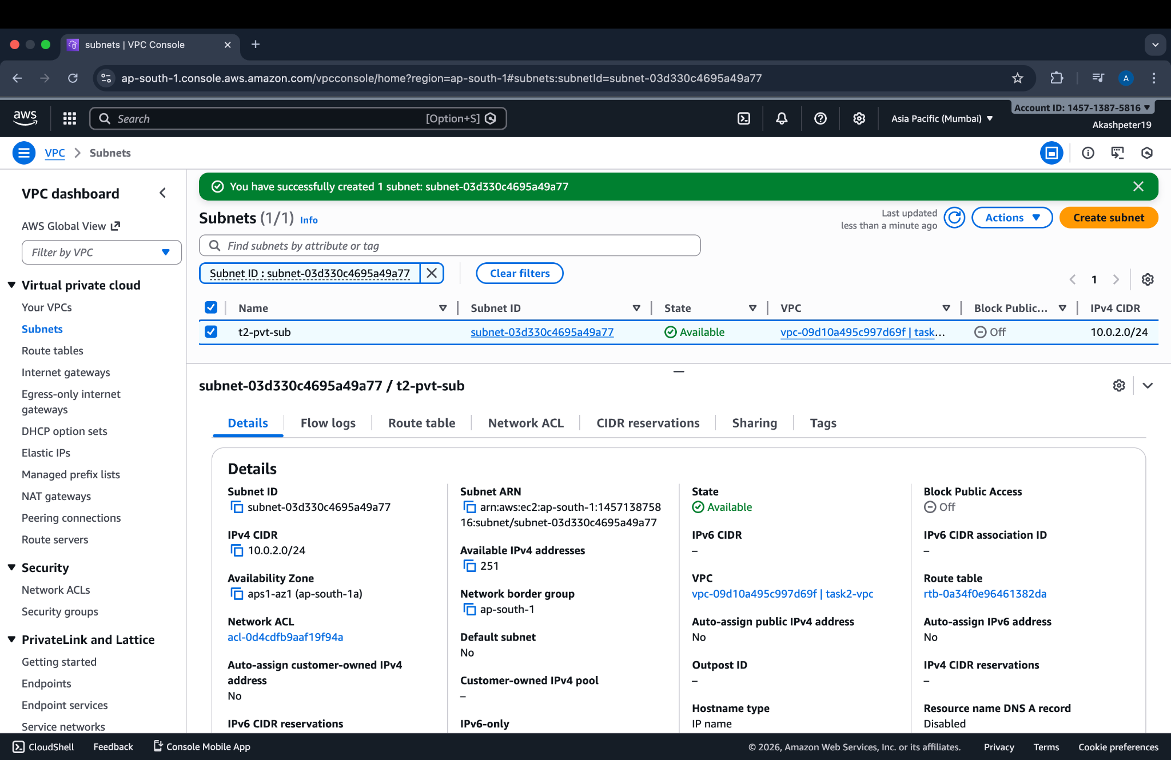
This screenshot shows the private subnet created with CIDR block 10.0.2.0/24, which is isolated and does not have direct internet access.

Screenshot 5: Route Table Creation
This screenshot shows the route table created inside the VPC to control network traffic routing also the route table configured with a route to the Internet Gateway (0.0.0.0/0), allowing outbound internet access.
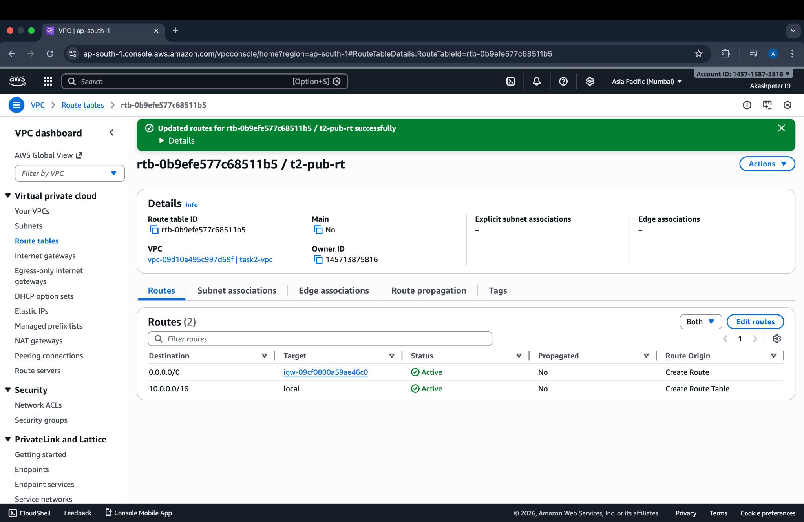

Screenshot 6: Route Table Subnet Association
This screenshot shows the public subnet associated with the route table, ensuring traffic from the public subnet is routed to the internet.
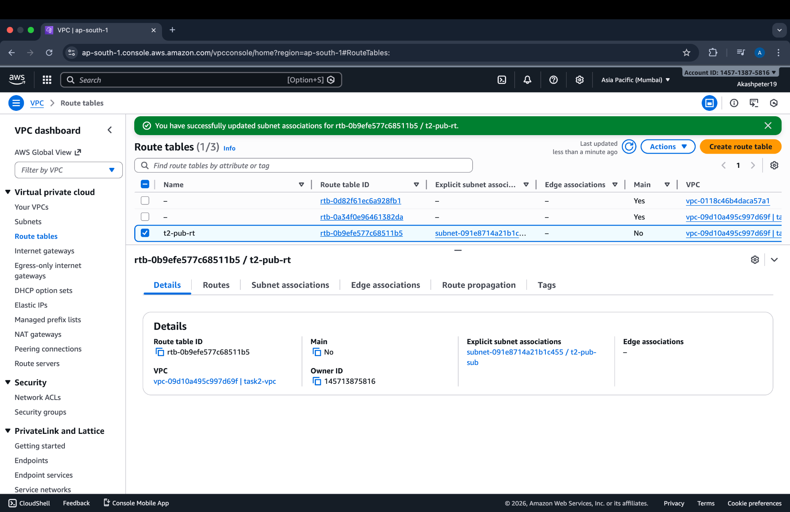

Screenshot 7: EC2 Instance Launch and Running Status

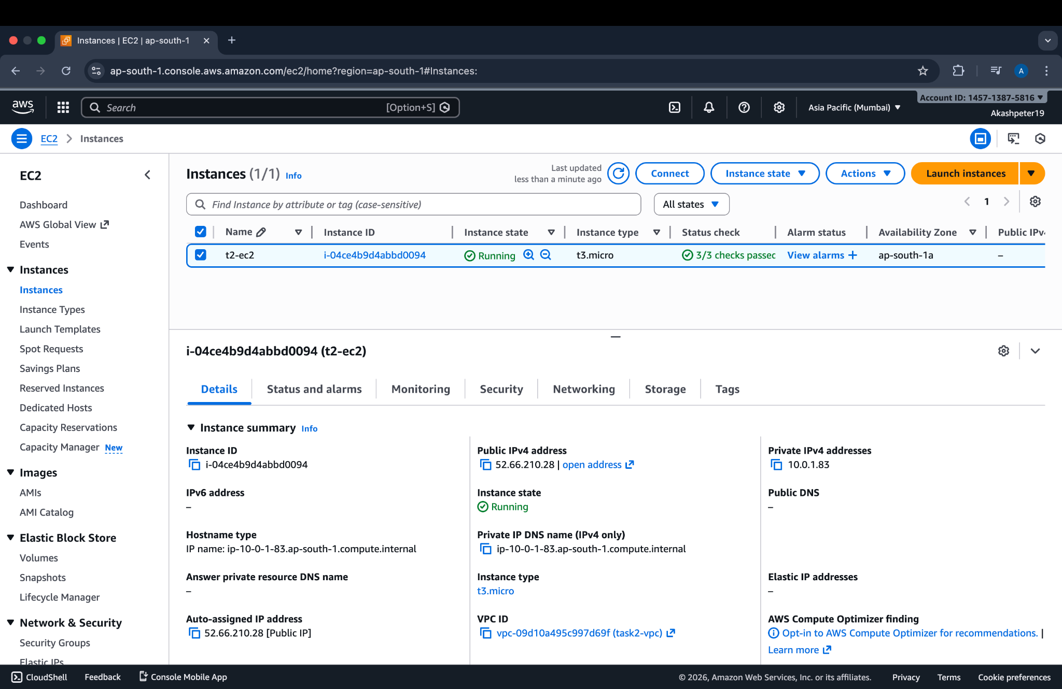
This screenshot shows the Linux EC2 instance launched using the custom VPC and public subnet, and confirms that the instance is running successfully with a public IP address assigned.

Screenshot 11: EC2 Public IP Access
This screenshot shows successful access to the EC2 instance using its public IP address, confirming internet connectivity.
